**Topics: Descriptive Statistics and Probability**

1. Look at the data given below. Plot the data, find the outliers and find out $μ, σ, σ^{2}$

|  |  |
| --- | --- |
| **Name of company** | **Measure X** |
| Allied Signal | 24.23% |
| Bankers Trust | 25.53% |
| General Mills | 25.41% |
| ITT Industries | 24.14% |
| J.P.Morgan & Co. | 29.62% |
| Lehman Brothers | 28.25% |
| Marriott | 25.81% |
| MCI | 24.39% |
| Merrill Lynch | 40.26% |
| Microsoft | 32.95% |
| Morgan Stanley | 91.36% |
| Sun Microsystems | 25.99% |
| Travelers | 39.42% |
| US Airways | 26.71% |
| Warner-Lambert | 35.00% |

Ans : mean = 33.274

* $σ^{2}$ = 287.101
* $σ$ = 16.944
* Outlier = 91.36

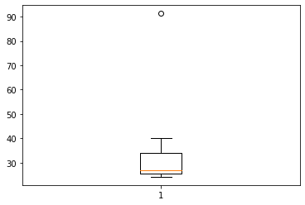



Answer the following three questions based on the box-plot above.

1. What is inter-quartile range of this dataset? (please approximate the numbers) In one line, explain what this value implies.

Ans = (upper quartile – lower quartile) = IQR : 12 – 5 = 7

1. What can we say about the skewness of this dataset?

Ans : Positively skewed

1. If it was found that the data point with the value 25 is actually 2.5, how would the new box-plot be affected?

Ans = The outlier will be removed

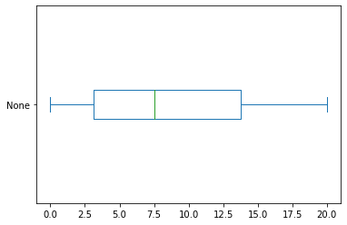



Answer the following three questions based on the histogram above.

1. Where would the mode of this dataset lie?

Ans = between 4 to 8

1. Comment on the skewness of the dataset.

Ans = Positively skewed

1. Suppose that the above histogram and the box-plot in question 2 are plotted for the same dataset. Explain how these graphs complement each other in providing information about any dataset.
2. AT&T was running commercials in 1990 aimed at luring back customers who had switched to one of the other long-distance phone service providers. One such commercial shows a businessman trying to reach Phoenix and mistakenly getting Fiji, where a half-naked native on a beach responds incomprehensibly in Polynesian. When asked about this advertisement, AT&T admitted that the portrayed incident did not actually take place but added that this was an enactment of something that “could happen.” Suppose that one in 200 long-distance telephone calls is misdirected. What is the probability that at least one in five attempted telephone calls reaches the wrong number? (Assume independence of attempts.)

Ans = 0.02475

1. Returns on a certain business venture, to the nearest $1,000, are known to follow the following probability distribution

|  |  |
| --- | --- |
| x | P(x) |
| -2,000 | 0.1 |
| -1,000 | 0.1 |
| 0 | 0.2 |
| 1000 | 0.2 |
| 2000 | 0.3 |
| 3000 | 0.1 |

1. What is the most likely monetary outcome of the business venture?

Ans = 2000 because it has maximum probability = 0.3

1. Is the venture likely to be successful? Explain

Ans= yes the probability that the venue will make more than 0 or a profit

P(x>0)+p(x>1000)+p(x>2000)+p(x=3000) = 0.2+0.2+0.3+0.1 = 0.8

It means that there is 80% chance for this venture to be making a profit

1. What is the long-term average earning of business ventures of this kind? Explain

Ans = the long term average is Expected Value = Sum(X * P(X)) = 800$

The average return will be more than 800$

1. What is the good measure of the risk involved in a venture of this kind? Compute this measure

Ans = The good measure of the risk involved in a venture of this kind depends on the variability in the distribution .Higher Variance means more chances of risk Var(X) = E(X^2)-(E(X))^2 = 2800000- 800^2 = 2160000